Walter Veith Healthy Brown Bread
Dry Ingredients:
7 cups of Stone Ground Whole Wheat flour. I use Bob’s Red Mill 100% Stone Ground Whole Wheat
1 package of yeast 10 grams. About 2 ½ tsp.
4 Tablespoons finely chopped flaxseed or linseed.
1 tablespoon salt. I use Ground Himalayan Pink Salt.
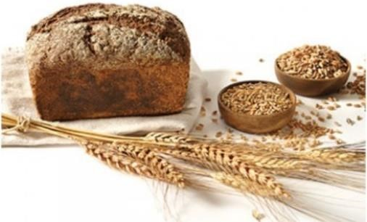
Mix all dry ingredients - wheat, yeast, salt, and ground flaxseed in large bowl.
Wet Ingredients:
3 2/3 cup to 4 cups warm water. I just use hot water out of the tap. You can warm water on the stove if you prefer.
1 tablespoon molasses.
Wisk or stir molasses in with the warm water.
Pour water and molasses solution into the bowl with the dry ingredients. Mix with a large spoon until the dry ingredients are bound together with the liquid.
Make sure your hands are washed.
Knead by hand for about 6 minutes – Watch Walter Veith video on Healthy Brown Bread. https://www.youtube.com/watch?v=1XMAuuNXpZE
Cover and leave kneaded dough in bowl in a warm place for about 20 minutes. Contents should double. Be gentle with the bowl. No banging.
Then gently knead dough for a minute or so. Split dough in half and put in two bread pans. I use two non stick XL 9.7” x 5.75” x 2.8 loaf pans.
Wet your hands and shape the top of dough in the pan so it is rounded on top.
Then let it sit another 20 minutes or so. Again, no banging. Begin to pre-heat the oven to 420 F.
After the bread has risen in the bread pans gently pick them up and place them in the oven.
Leave at 420 degrees F for about 5 minutes.
Reduce to heat to 400 degrees F.
Bake for about 50 minutes. Use a kitchen timer or timer on your phone.
Take out and let it cool down a few minutes.
Then take the loafs out of the pans cover and let them cool.

Tofurky Sandwich
- packages of Tofurky – about $3 each. Can be purchased at Fred Myers, Target, Whole Foods
- or four Tablespoon of Vegenaise – about $8/qt. Can be purchased at Fred Myers, Target, Safeway
¼ of medium sized yellow onion 2 cloves of Garlic
Add to Tofurkey, Garlic and Onion to food processor and mix. Then put in a bowl and mix in Vegenaise. Spread on your favorite bread and enjoy.

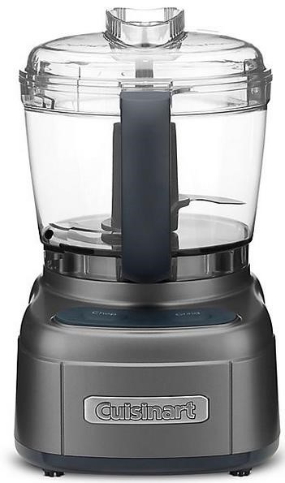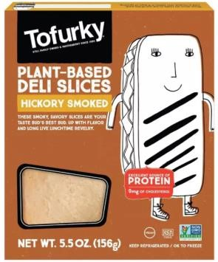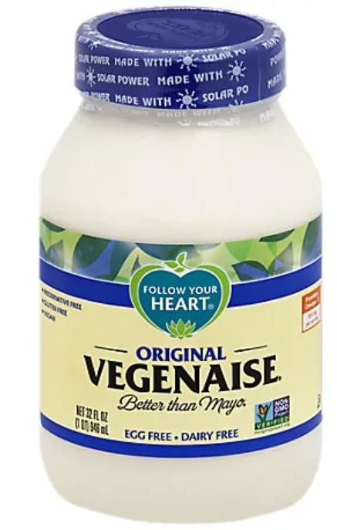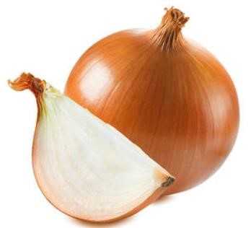

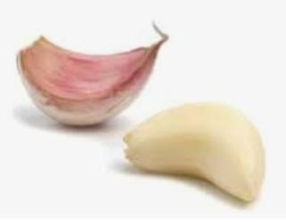

Chicken Style Seasoning Recipe from Annette Davis

Large Recipe: Small Recipe:
- 4 c. nutritional yeast flakes ½ c. nutritional yeast flakes
- 2/3 c. onion powder 1 ½ T. onion powder
- 2/3 c. salt 1 ½ T. salt
- ½ c. Italian seasoning 1 T. Italian seasoning
- 1/3 c. dried parsley ¾ T. dried parsley
- ¼ c. sucanat or cane juice crystals ½ T. brown sugar (sub for sucanat)
- 3 T. garlic powder ½ t. garlic powder
- 1 ½ t. celery seed Pinch of celery seed
- ¾ t. cayenne pepper Pinch of cayenne pepper

Blend all ingredients in a blender until very fine and store in an air tight container.

Tofu Croutons Recipe from Annette Davis
Rinse under cold water 1 block of firm or extra firm tofu and dry well with paper towels. Slice into 8-12 pieces (depending on how thick you’d like it) and cut in half again to make 16-24 squares. Make marinade of 2/3 c. water and 1 – 1 ½ T. Chicken Style Seasoning (depends on how strong you prefer). Place tofu squares in container and pour marinade over them. Marinate overnight or longer. Drain broth and place squares in frying pan with some olive oil on medium heat. Sprinkle nutritional yeast flakes on top then turn over and sprinkle other side. Fry until golden brown on both sides. Cut into crouton shapes. Good for many things i.e., on top of salad, in stir-frys, or mashed and mixed with vegenaise and chopped celery and onions and olives for a sandwich filling, or just plain, as is!

Vegan 1000 Island Dressing Marla Danielson/Class 35 July 25, 2021

Ingredients:
- 1 c. vegenaise (Follow Your Heart brand, reduced fat)
- ¼ c. tomato sauce (no salt added)
- 1 T. agave
- ½ t. onion powder
- ¼ t. garlic powder
- ¼ t. each: dill, paprika
- 1 T. dill pickle relish

Directions:
Place all ingredients in a small bowl and whisk or stir together. Enjoy!

Fresh Garden Salad Marla Danielson
- Fresh garden produce chopped, diced and shredded: lettuce, cucumbers, zucchini, carrots, onions, cabbage, basil
- Fresh Avocados, diced or sliced
- Fresh Tomatoes
- Tofu Croutons
- Roasted, salted pumpkin seeds
- Fresh blueberries
- Fresh Cilantro
Toss fresh garden produce together and garnish with avocados, tomatoes, tofu croutons, pumpkin seeds, fresh blueberries and fresh cilantro.

Vegan Banana Pudding Berry Parfaits Marla Danielson/Class 35 July 25, 2021

Ingredients:
- 1 c. vegan vanilla yogurt
- ½ banana, mashed
- 2 gingersnap cookies
- 1/2 c. fresh strawberries, chopped
- 1/4 c. fresh blueberries
- Your favorite granola to sprinkle on top

Directions:
- Stir together mashed banana and yogurt to make easy banana pudding.
- Layer in clear cup:
1 cookie, broken
Banana pudding
Fresh berries
1 cookie, broken
Banana pudding
Fresh berries
Banana pudding
Your favorite granola

Did You Know?
https://www.healthline.com/nutrition/foods/bananas, https://10faq.com/health/health-benefits-of-strawberries

Bananas are a healthy source of fiber, potassium, vitamin B6, vitamin C, and various antioxidants and phytonutrients.

The strawberry we know today is actually a hybrid that was first developed in France. It is not technically a berry, but rather an aggregate accessory fruit. Regardless of technicalities, it is one of the most popular of all ‘berries’ and is enjoyed all over the world.

Strawberries are low in calories yet high in nutrition, making them ideal for people that are on weight loss diets. They are also suitable for diabetics and are even thought to be able to soothe the symptoms of arthritis.

